**Adaptive Headlight and Emergency Break Alert System**

Amey R Gunde1, Sanket B Mutnale2, Aniket T Takkekar3, Sushil R Sankpal4

Final Year Engineering Students1,2,3, Assistant Professor4

Department of Electronics and Telecommunication Engineering, Sant Gajanan Maharaj College of Engineering, Mahagaon Maharashtra, India.

**ABSTRACT**: In a world where mobility is synonymous with progress, road safety stands as a fundamental pillar of civilization. Every journey embarked upon, whether a short commute or a long-haul expedition, carries with it inherent risks. With the advancements in vehicular technology, the evolution of driving norms, and the ever-expanding network of roads, the need for a comprehensive understanding of road safety has never been more paramount. This report delves into the multifaceted realm of road safety, focusing particularly on the nuances of driving practices, the challenges posed by night driving, and the critical maneuvers involved in emergency braking. From mastering the art of defensive driving to navigating through congested urban centers, drivers encounter a myriad of situations demanding their utmost attention and expertise. This section of the report aims to dissect the various facets of driving, shedding light on effective strategies, common pitfalls, and the role of technology in enhancing driver safety. The cloak of darkness brings forth a unique set of challenges for drivers, amplifying the risks inherent in road travel. Reduced visibility, impaired depth perception, and increased likelihood of encountering fatigued or intoxicated drivers pose significant threats to night-time commuters. By understanding these road safety challenges and learning practical strategies to address them, drivers can significantly improve their ability to navigate night time roads with confidence. This report equips readers with the knowledge and skills to manage headlight glare, execute emergency braking maneuvers effectively, and ultimately, arrive at their destinations safely.

KEYWORDS: Road Safety, Night Driving, Automation, Accident Prevention, Advance Headlights.

1. **Introduction**

The project aims to tackle road safety concerns by implementing innovative solutions targeting two key areas. The first initiative focuses on mitigating accidents caused by the blinding glare of upper lamps from oncoming vehicles. To address this, an adaptive headlight system will be developed and integrated into vehicles. This system will utilize advanced sensors and image recognition technology to dynamically adjust the direction and intensity of the vehicle's headlights. By automatically responding to the presence of oncoming vehicles, pedestrians, and varying road conditions, the adaptive headlight system aims to reduce glare and improve visibility for both the driver and other road users [1].

In parallel, the project addresses the need to minimize the risk of rear-end collisions through the implementation of Flashing Brake and Hazard Systems. These systems are designed to enhance communication between vehicles, thereby reducing reaction times and enhancing overall road safety. When the vehicle's sensors detect sudden deceleration, the Flashing Brake and Hazard Systems will activate, causing the vehicle's brake lights and hazard lights to flash rapidly. This visual alert will effectively inform following drivers of the abrupt stop or potential danger ahead, encouraging them to react promptly and safely [2].

1. **Related work**

|  |  |
| --- | --- |
| **Ref.** | **Findings** |
| [3] | -The BH1750 sensor operates by converting light intensity into digital values, making it suitable for measuring ambient light levels accurately.  -Integration of the BH1750 sensor with smart lighting systems enables automatic adjustment of LED light brightness according to ambient light conditions. |
| [4] | -Matrix headlights offer advantages over traditional LED headlights, providing a wider range of lighting and more precise illumination.  - The use of AI-based controller control enables matrix headlights to automatically adjust brightness and lighting patterns according to environmental factors such as light intensity and human presence. |
| [5] | -This article is based on Vibration monitoring system which is operated on ADX335 accelerometer and Arduino 2560 interface.  -It gives the detail information related to accelerometer and vibrating motors. |
| [6] | The paper provides a comprehensive overview of the SPI protocol, including its architecture, signal descriptions, and data transmission modes. It emphasizes SPI's high-speed, full-duplex, and synchronous communication capabilities, making it suitable for microcontroller-peripheral communication. |
| [7] | -The paper provides a comprehensive overview of the I2C protocol, highlighting its simplicity, bidirectional nature, and multi-master capability.  -Various aspects of I2C protocol operation are explained, including the roles of SDA and SCL lines, addressing modes, and data transfer mechanisms. |
| [8] | -The paper proposes a comprehensive solution for designing a CAN bus protocol for research applications in hybrid electric vehicles (HEVs) using an ARM microcontroller. It addresses the need for a multi-master communication protocol to replace centralized control systems.  -The paper effectively utilizes the Controller Area Network (CAN) protocol, known for its multicast-based communication and deterministic resolution of contention, making it suitable for automotive applications. |

1. **Circuit Diagram**

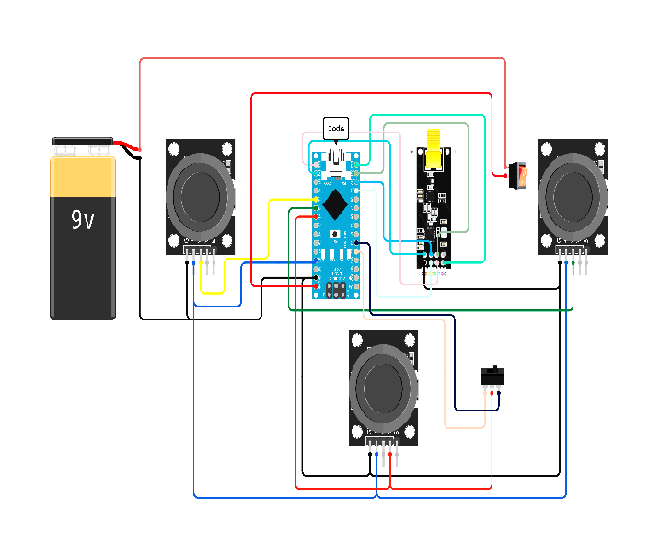

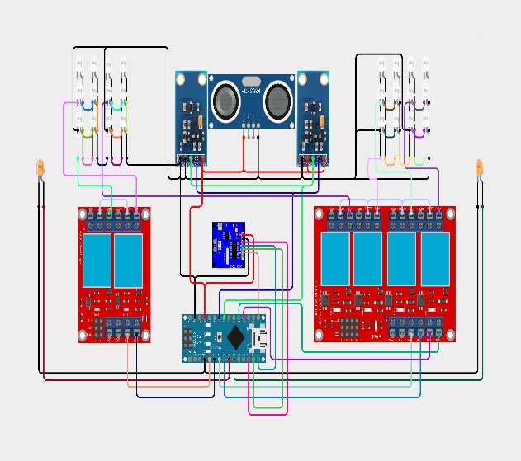

**Fig No.1** **Circuit Diagram of Remote Fig No.2** **Circuit Diagram of Front Section**

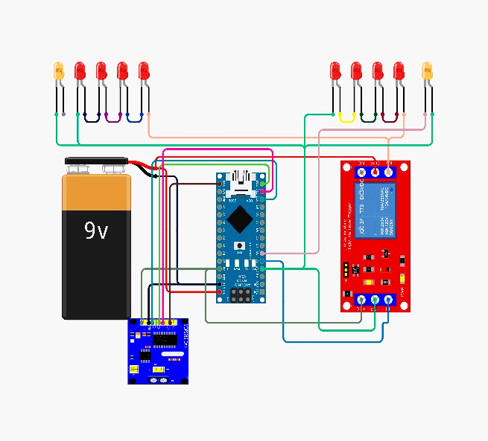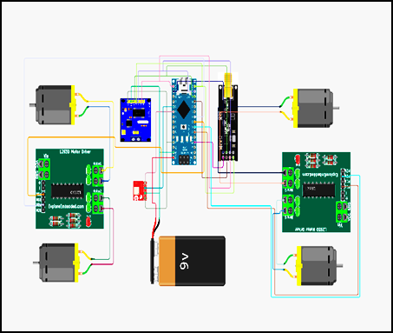

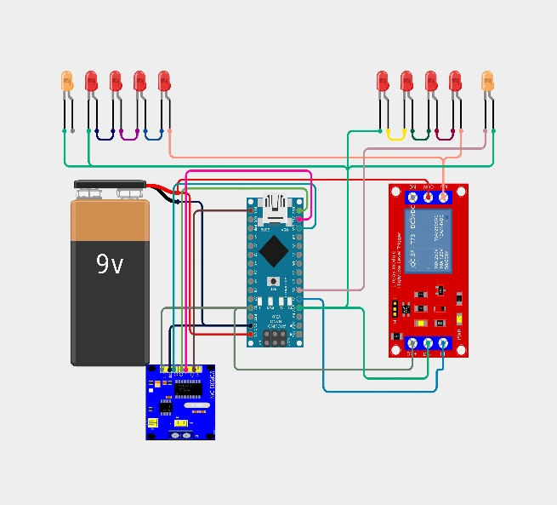

**Fig No.3** **Circuit Diagram of MCU Fig No.4 Circuit Diagram of Back Section**

1. **Hardware Implementation:**

The Fig No.5 illustrates the mounting of various components on a Printed Circuit Board (PCB) board, including Arduino UNO, Arduino NANO, Light Intensity Sensor Module, ADXL335 module, Ultrasonic Distance Measuring Sensor Module, MCP2515 CAN Bus Module, TA6586 Based Motor Driver Module, NRF24L01, and Matrix LED Headlight.

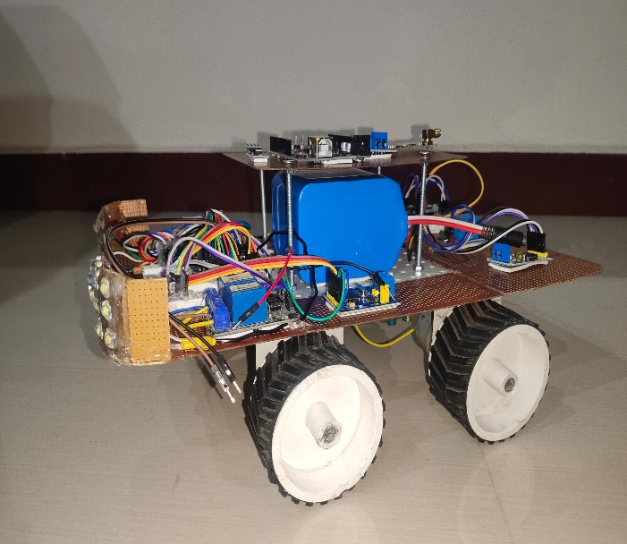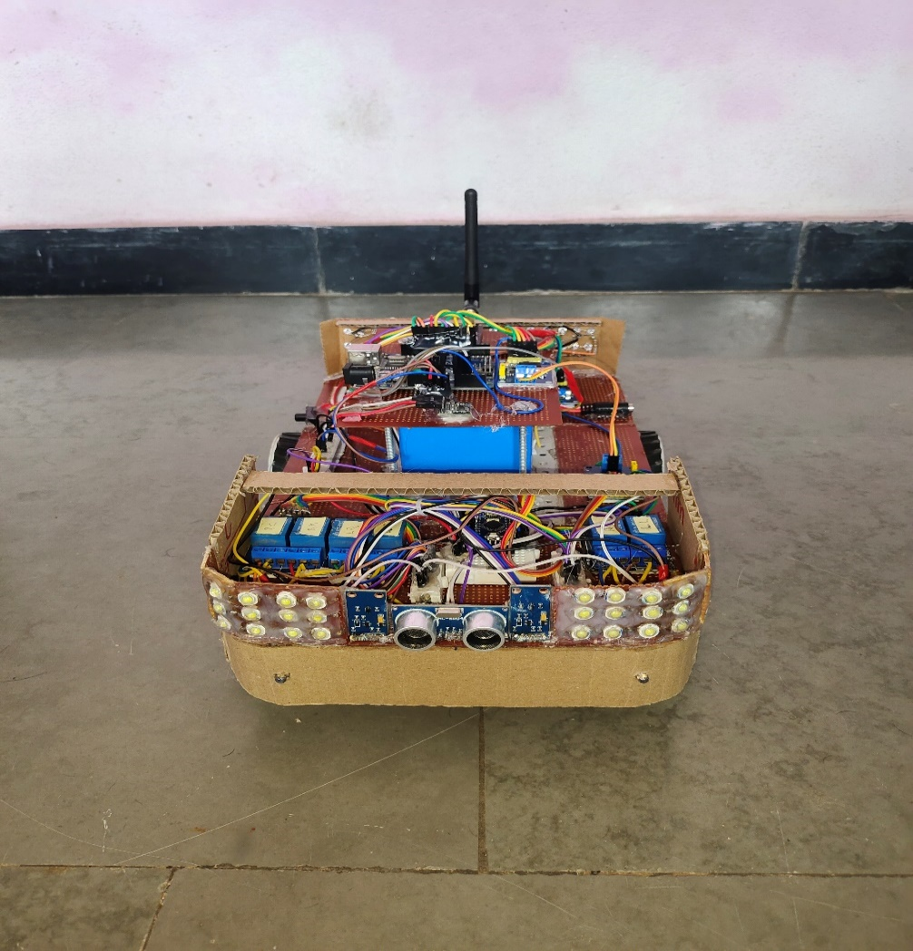

**Fig No.5** **Implemented Circuit**

# **The following section gives the details regarding hardware used for the implementation.**

1. **Arduino UNO:**

The Arduino UNO is a popular micro-controller board, based on the ATmega328P chip, used to control devices and manage peripherals. It has 14 digital and six analog inputs, a 16 MHz quartz crystal, USB connection, and a power jack. Programming is easy using the Arduino programming language.

1. **Light Intensity Sensor Module:**

The BH1750 is a digital light sensor that accurately measures ambient light intensity, enabling applications like automatic lighting control, backlight dimming, and smart home automation. Its small size and low power consumption make it versatile [9].

1. **Ultrasonic Level Sensor Module:**

The Ultrasonic Level Sensor Module is a reliable and accurate distance measurement tool used in automotive safety systems, industrial automation, and robotics. It detects nearby objects and obstacles, enhancing safety by providing timely warnings and autonomously adjusting speed.

1. **ADXL335 Module:**

The ADXL335 module, a three-axis accelerometer, measures acceleration in three dimensions, enabling applications like tilt sensing, motion detection, and vibration monitoring. Its data is crucial for stability control systems, rollover detection, and vehicle safety [10].

1. **NRF24L01:**

The NRF24L01 is a low-cost wireless transceiver module suitable for microcontroller-based devices, providing robust data transmission over short distances. Its configurable parameters allow for optimization and is widely used in remote control, sensor networks, and IoT applications [11].

1. **MCP2515 CAN Bus Module:**

The MCP2515 CAN Bus Module is a versatile CAN controller with SPI interface, ideal for automotive, industrial automation, and IoT devices. It supports standard and extended message formats and various baud rates, facilitating seamless data exchange and real-time coordination [12].

1. **Flow Chart of System:**

For the implementation of the proposed systems the flow charts discussed below considered:

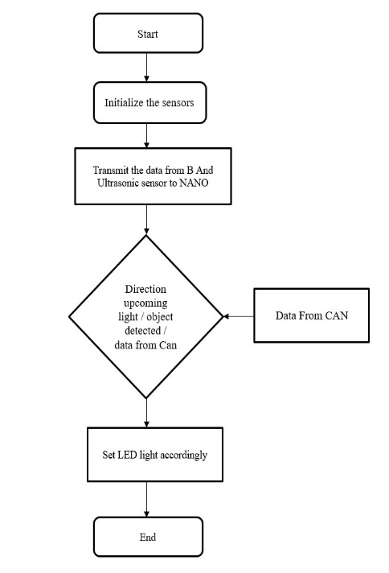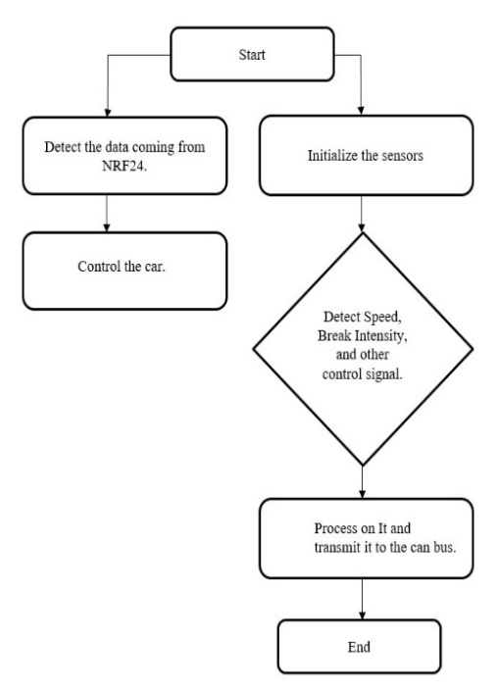

**Fig No.6** **Flow Chart of Front Section**

**Fig No.7** **Flow Chart of MCU**

Fig No.6 represents the flowchart of front section module helps to understand the steps which are required to perform the operation. It includes algorithm steps based on programming done in Embedded C in Arduino IDE software tool. This Flowchart steps can be useful for operations performed front section operation.

Fig No.7 represents the flowchart MCU, it starts with data input from the nRF24 module, initializes the sensor, and then further branches into detecting the speed, brake intensity, and other control signals. After collecting the data, it then enters into processing for the extraction of insights. The processed data is finally sent to the CAN bus for integration, ensuring seamless communication within the vehicle's network. It is this coherent method that helps in highly effective utilization of data from the nRF24 module for enhanced vehicle safety, performance, and overall functionality within the CAN bus network.

At the back section, this process starts with receiving data from the CAN bus, then it is system initialization. Then it detects the normal and emergency brake signals. It flashes the backlight accordingly on the basis of the signals. This well-structured process controls the data from the CAN bus for effective and prompt monitoring and control, thereby ensuring that drivers get a visual clue during the braking event.

1. **RESULTS:**

The results of the implemented system tested for following Modules:

* + - Front vehicle detection.
    - Upcoming Vehicle detection.
    - Road curve detection.
    - Tilt detection
    - Emergency breaking and normal breaking detection.

1. **Front Vehicle Detection:**

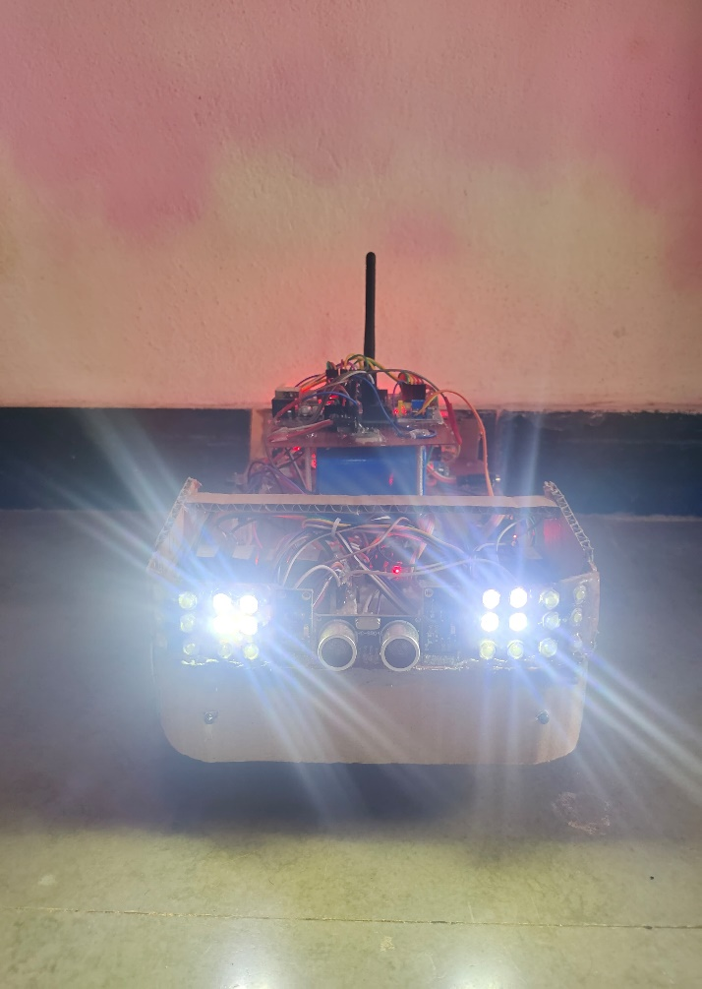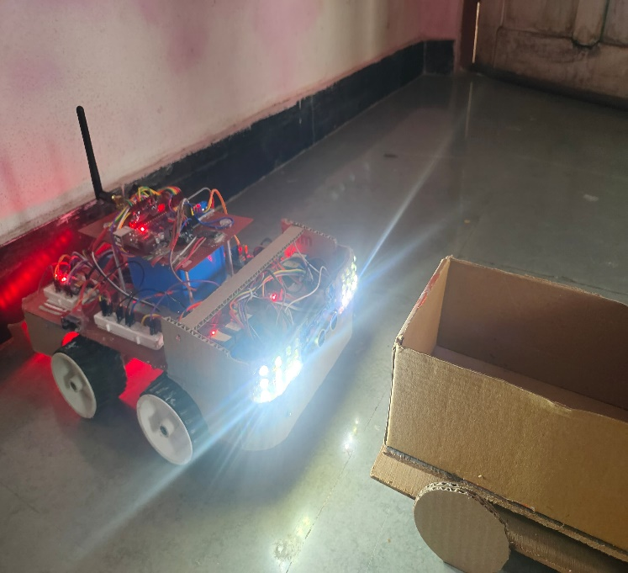The below Fig 8 shows the actual working of system, when a vehicle is detected in front of the car by the ultrasonic sensor, the response is twofold to mitigate glare and ensure safety. Firstly, the headlights automatically switch from high beam to lower beam to reduce glare for the approaching vehicle. This adjustment maintains visibility for the driver while minimizing discomfort for the oncoming driver. Secondly, the corner lights are activated to provide additional illumination around the periphery of the vehicle, enhancing visibility without causing additional glare.

**Fig No.8 High Beam Fig No.9 Low Beam on Vehicle Detection**

In Figure 8, the LED represents the high beam state of the headlights, indicating maximum illumination for improved visibility. However, when a vehicle is detected in front of the car, as depicted in Figure 9, the system triggers a transition from high beam to low beam. This adjustment ensures that the headlights emit a less intense light, reducing glare for the approaching vehicle while still providing adequate illumination for the driver's visibility.

1. **Upcoming Vehicle detection:**

Figure 10 shows, one instance where the vehicle is detected on the left side or right side from the vehicle's system. On the left side when the vehicle was sensed by the left-side BH1750 light sensor, the system turns on the left side high beam to go to the low beam. The left-side corner light was also turned on to provide more visibility around the corner by minimizing glare. On the other hand, if a vehicle was detected on the right side by the right-side BH1750 sensor, the system will turn off the right-side high beam and go on to switch the low beam on. These smart changes will provide a relatively safe driving situation with adequate visibility for the driver of the vehicle with this system while minimizing glare for other drivers.

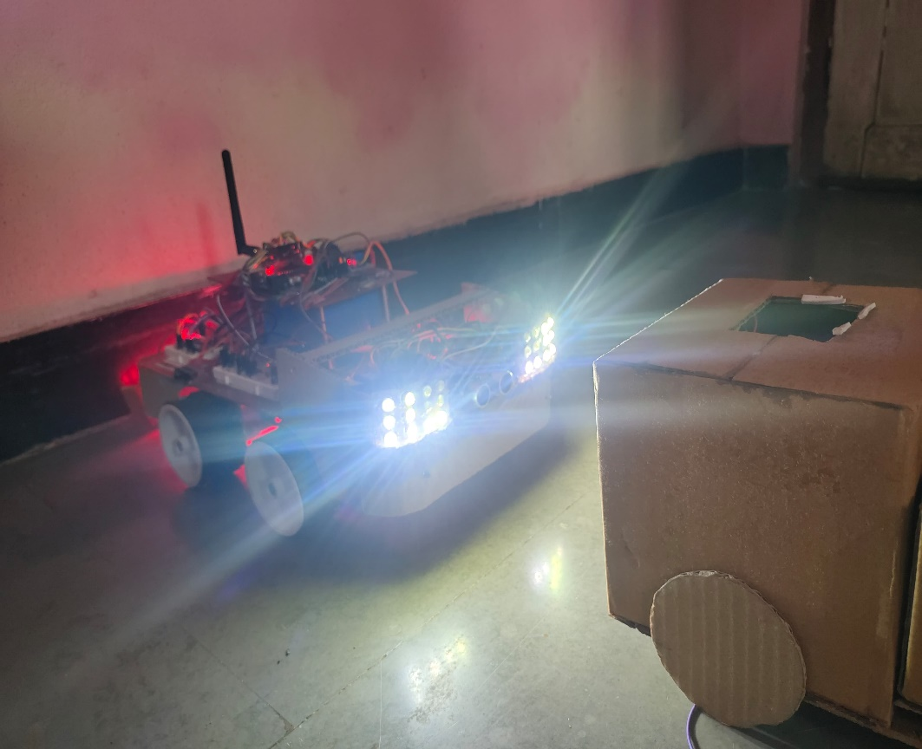

**Fig No.10 Low Beam on detecting the upcoming vehicle**

1. **Road curve detection:**

Figure 11 below shows the system in operation, whereby the corner lights are switched on in specific events. The first is when a corner of the road is reached; the corner lights automatically switch on to increase visibility around the corner to ensure that the driver navigates safely. In the second instance, when the driver makes a turn by rotating the steering wheel, the corner lights for that side are switched on to increase visibility in the direction of the turn to further assist in navigating safely. In the third instance, when a turn indicator is activated, the corner lights for that side are also activated, in addition to providing an extra visual aid to all road users and ensuring overall safety during a lane change or turn. These intelligent variations ensure the best illumination and visibility to assist the driver to traverse challenging road conditions more effectively.

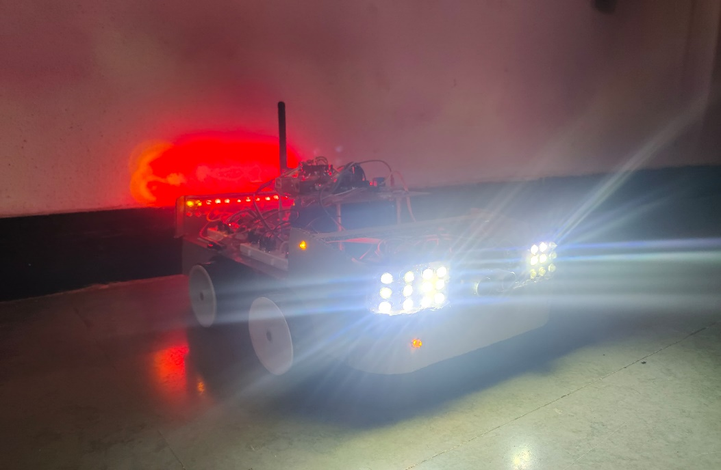

**Fig No.11 Corner Lights On When Indicator Turns On**

1. **Tilt detection**

This system will activate the high beam headlights when the car tilts. The adjustment probably targets improving visibility by the driver on all kinds of situations where a tilted car may find the road ahead obscured—like driving steep inclines or uneven terrain. This way, the system automatically activates the high beam headlights in such situations to ensure the driver has proper illumination to safely navigate the bad road conditions and hence improved safety.

1. **Emergency breaking and normal breaking detection.**

The system uses sensors to detect the velocity of the car and the severity of braking. In case a sudden and severe braking is detected, which clearly indicates an emergency, the system activates the flashing of the backlight at 5Hz. This flashing will provide a visual warning to other road users, pedestrians, and vehicles around that car is performing an emergency braking maneuver, hence reduces the possible risk of a collision. When not in emergency braking, the backlight turns on without flashing in case of normal braking.

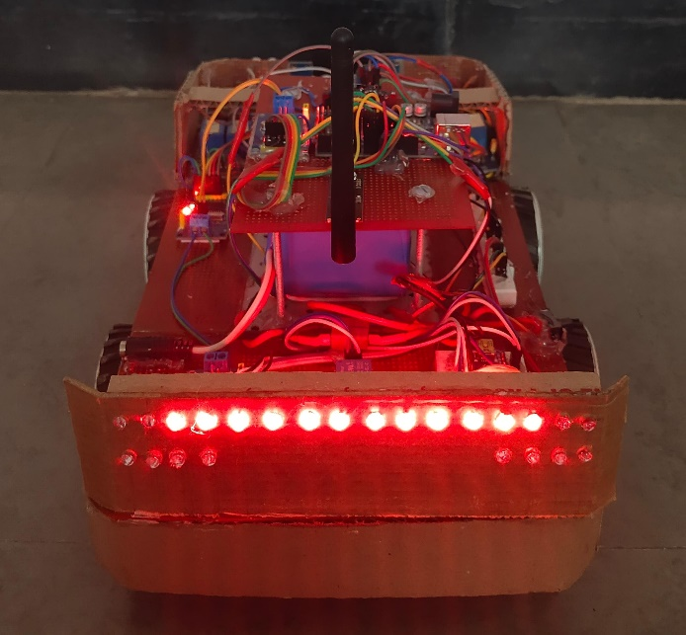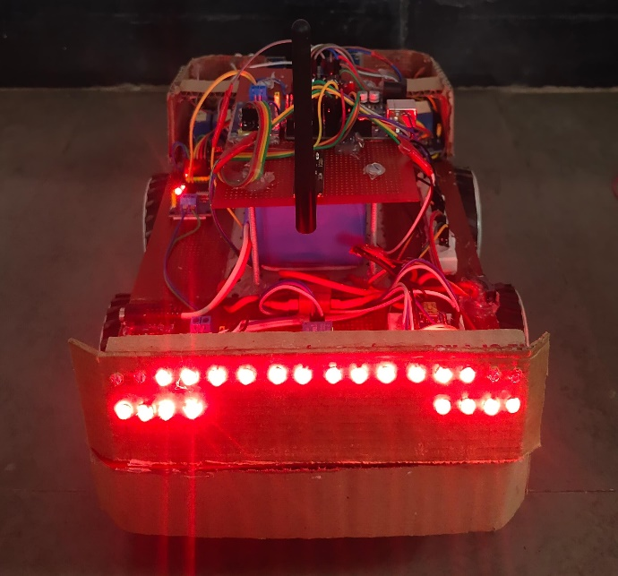

**Fig No.12 Normal Breaking Fig No.13 Emergency Breaking**

1. **Conclusion**

In our research, we have successfully developed an Adaptive Headlight and Emergency Braking System designed to enhance road safety during nighttime driving. Through meticulous integration of cutting-edge technologies, our system effectively addresses critical aspects of driver visibility and response to potential hazards. By leveraging front vehicle detection capabilities, the system swiftly adjusts headlight beams to reduce glare for oncoming vehicles while ensuring optimal visibility for the driver. Moreover, intelligent management of high and low beams, facilitated by light sensors, enhances safety without compromising visibility, particularly when vehicles approach from the sides. The integration of corner lights anticipates road curves, aiding in safer navigation, and the activation of high beam headlights in response to vehicle tilting ensures essential illumination in challenging terrain conditions.

A cornerstone of our system's functionality lies in its ability to distinguish between normal and emergency braking events. Through flashing brake lights during emergency stops, our system effectively alerts following vehicles to potential hazards, thereby reducing the risk of rear-end collisions. This comprehensive approach to nighttime driving safety underscores our commitment to developing intelligent solutions that prioritize driver well-being and promote safer roadways.

1. **references**
2. Ms. Aishwarya J. et al “Adaptive Headlight System for Automobiles” International Journal of Engineering Research & Technology (IJERT) ISSN: 2278-0181 [2020].
3. JESSE PIRHONEN “Predictive Braking with Brake Light Detection—Field Test” IEEE assess Digital Object Identifier 10.1109/ACCESS.2022.3173416 May 9, 2022.
4. Linfeng Jia et al. “Design of a Smart Lighting System Based on Sensor Integration and Automation”.
5. Jiang Li. “A Matrix Headlamp Design Based on Artificial Intelligence Controller Control”, Journal of Physics: Conference Series, ICCASIT 2020.
6. Keshav H. Jatakar et al. “Vibration monitoring System based on ADXL335 accelerometer and Arduino 2560 interface”, Journal of Algebraic Statistics Volume 13, (2022).
7. Pallavi Polsani et al. “Design & Verification of Serial Peripheral Interface (SPI) Protocol”, International Journal of Recent Technology and Engineering (IJRTE) ISSN: 2277-3878 (Online), Volume-8 Issue-6, March 2020.
8. Dr. Sagar Patelet al. “Design of I2C Protocol”, International Journal of Technical Innovation in Modern Engineering & Science (IJTIMES) Volume 5, Issue 03, March-2019.
9. Kristian Ismail et al. “Design of CAN bus for research applications purpose hybrid electric vehicle using ARM microcontroller”, 2nd International Conference on Sustainable Energy Engineering and Application, ICSEEA 2014.
10. Linfeng Jia “Design of a Smart Lighting System Based on Sensor Integration and Automation”, Vol. 1 No. 5 : Issue 5, Dean&Francis (2024).
11. Keshav H. Jatakar, Gopal Mulgund, A D. Patange, B B. Deshmukh, “Vibration monitoring System based on ADXL335 accelerometer and Arduino Mega2560 interface”, JOURNAL OF ALGEBRAIC STATISTICS Volume 13, No. 2, p. 2291-2301 ISSN: 1309-3452,2022.
12. Mobasshir Mahbub “Design and Implementation of Multipurpose Radio Controller Unit Using nRF24L01 Wireless Transceiver Module and Arduino as MCU” Article in International Journal of Digital Information and Wireless Communications · September 2019.
13. H Shambhavi, Dr. Devraju R “AUTOMIZING CAN COMMUNICATION SYSTEM USING RASPBERRY-PI” International Research Journal of Modernization in Engineering Technology and Science Volume:04/Issue:09/September-2022.